Yalda T. Uhls, PhD
Media Moms & Digital Dads
Screens and Children – Separating the Facts from Fear
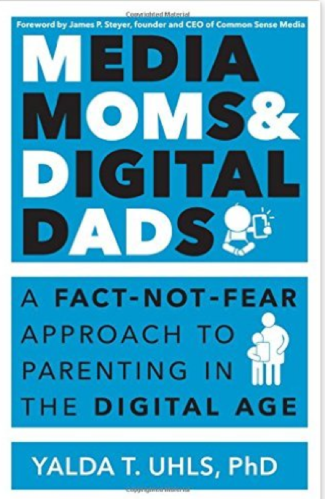

This presentation will provide an overview of the digital media landscape in which our kids live, learn, and play.

Discussion topics will include:

- Media usage, social science research, opportunities and challenges presented by digital media
- How parents can navigate this rapidly evolving landscape with their kids
- Expert advice on how parents can guide their kids to make responsible, respectful, and safe media choices

Yalda T. Uhls PhD is an award-winning child psychologist and expert in how media affects children. Her book, Media Moms and Digital Dads distills academic research focused on the impact of technology on children and breaks down the issues to make them actionable for parents. Yalda also works with Common Sense Media, the national non-profit, on research and entertainment outreach. Dr. Uhls’ work with UCLA (featured in media outlets such as the NY Times and NPR) focuses on how older and newer media impacts the social behavior of preadolescents. In her former career, she was a movie executive at MGM and Sony. Most importantly, she is a mom of two digital teens.

Visit Yaldatuhls.com to learn more about her work.

