Media Moms & Digital Dads
Screens and Children - Separating the Facts from Fear
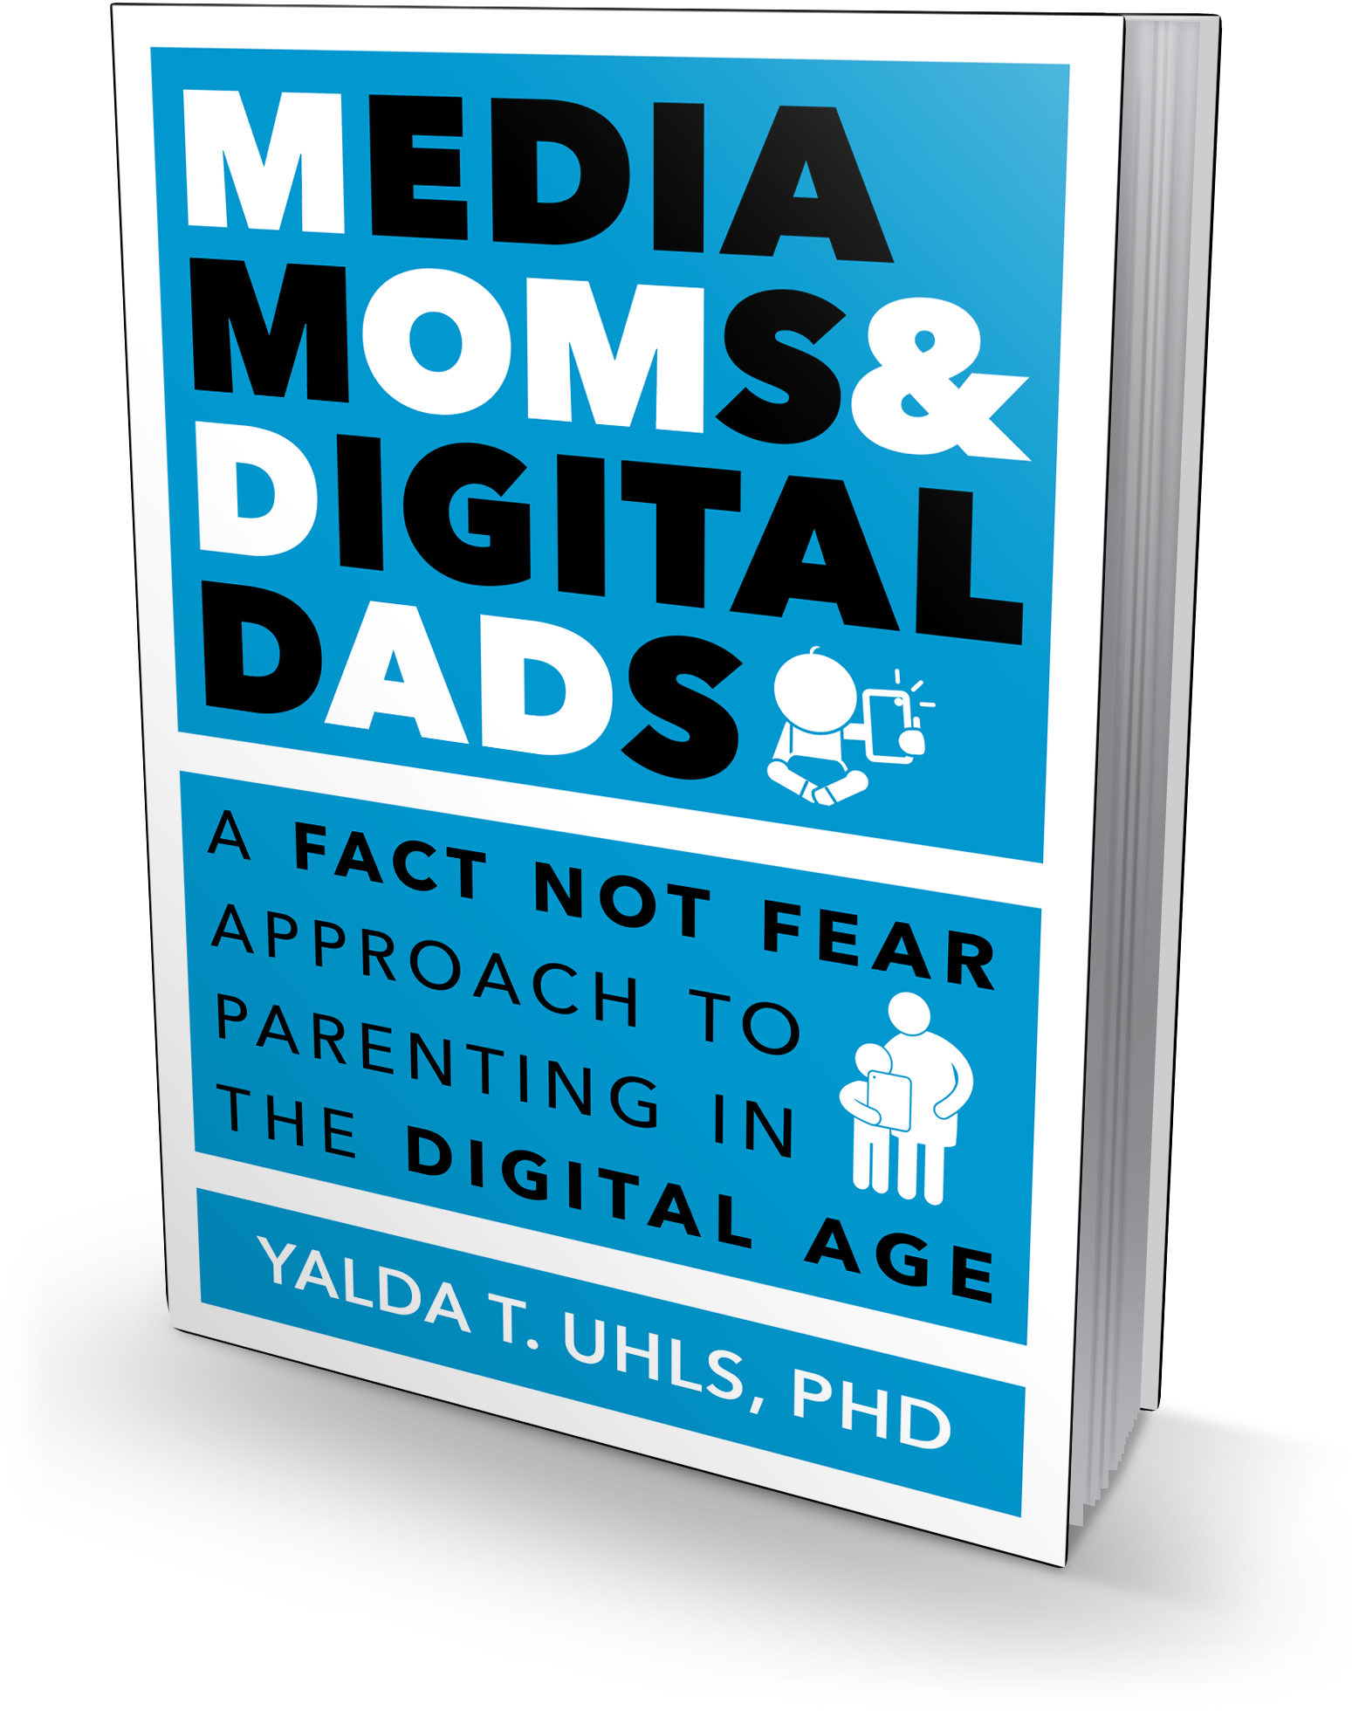
Media Moms & Digital Dads: Screens and Children Separating the Facts from Fear provides an overview of the digital media landscape in which our kids live, learn, and play. We’ll discuss media usage, social science research, opportunities and challenges presented by digital media, and how parents can navigate this rapidly evolving landscape with their kids. Yalda T. Uhls will offer expert advice on how parents can guide their kids to make responsible, respectful, and safe media choices.

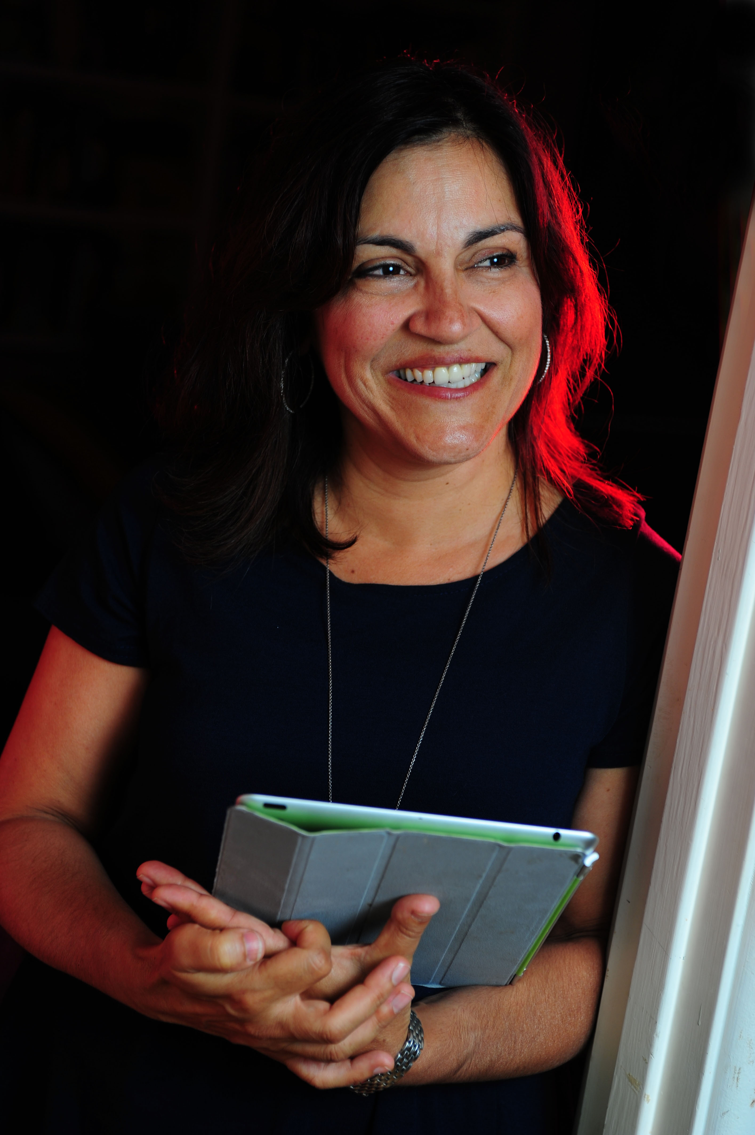
Yalda T. Uhls PhD is an award winning child psychological researcher and an expert in how media affects children. Her new book, Media Moms & Digital Dads, which was an Amazon #1 New Release in Child Psychology, distills peer-reviewed academic research focused on the impact of technology on children, breaking down these complex issues in a friendly, accessible fashion. Yalda also works with Common Sense Media, the national non-profit, on their entertainment outreach. Dr. Uhls’ research with UCLA (featured in media outlets such as the NY Times and NPR) focuses on how older and newer media impacts the social behavior of preadolescents. In her former career, she was a movie executive at MGM and Sony. Most importantly, she is a mom of two digital teens (a boy and a girl). Visit yaldatuhls.com to learn more about her work.

